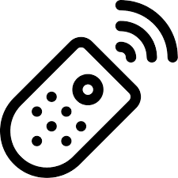

GATE REMOTE CONTROL NOTICE

The front gate equipment has been replaced. If your remote control does not work with the new equipment, please call Veracity at 214-368-3388 and provide the model and serial number of your remote so it can be re-programmed. If you need your telephone number programmed at the gate or if you wish to purchase a new remote control, just let the Veracity office know.

